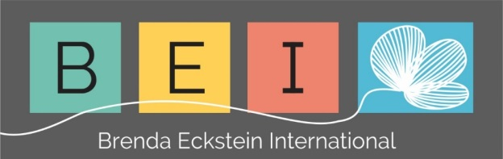
Brenda Eckstein International
P O Box 13366
Cascades
3202
Republic of South Africa
Phone: +27 82 4993311 Fax: + 27 86 5188 205
e-mail: brenda@strategy-leadership.com
Websites: www.strategy-leadership.com

September 5 2019

Preparation for the EYES course

Dear Participants,
I’m looking forward to the start of our Enhance Your Executive Skills (EYES) course. Prior to the course, if at all possible, please complete the following:
- Links to follow:
Links to the Positive Psychology video: https://www.youtube.com/watch?v=1qJvS8v0TTI

You might also like to have a look at this quick presentation by Jack Ma, founder of Alibaba.com: https://www.youtube.com/watch?v=N8BEdZ4fAQc

- VIA Strengths Test
‘Positive Psychology is the scientific study of the strengths that enable individuals and communities to thrive.’ This definition can be found on the University of Pennsylvania’s, Authentic Happiness website.
Please follow the full instructions below – you’ll enjoy the exercise:
Instructions for the VIA Strengths Test
Before starting, please make sure you can print from the device at the time of concluding your test. (Sometimes it is difficult to come back later and print.)
- Please press the following link:
https://www.authentichappiness.sas.upenn.edu/user/login?destination=node/434
- Log in with your Authentic Happiness username and password. If you haven’t used these tests before, you’ll need to register (free).
- Go to Questionnaires
- Select VIA Survey of Character Strengths (second to last in list of tests)
- Answer all 240 questions
- Print top five – 2 copies
- In addition, I’d appreciate your e-mailing a scanned copy to me brenda@strategy-leadership.com at least two days before the start of the programme. Thank you!

Enjoy these assignments. If you have any queries, you are welcome to send me an e-mail (my preferred form of communication).

Kind regards,

Brenda

