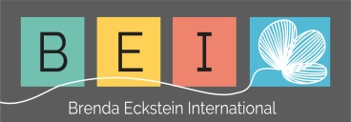

Brenda Eckstein

Business Consultant, Trainer and Integral Coach
Phone: +27 (0)33 342 5432 Mobile: +27 (0)82 499 3311 Fax: +27 (0)86 518 8205
E-mail: brenda@strategy-leadership.com
Website: www.strategy-leadership.com

June 2018
Individual workday energy graph

Instructions:

Please plot 3 separate graphs, using different colours for each of the following:

- average workday (colour 1)
- exciting workday (colour 2)
- exhausted workday (colour 3)

You may prefer to use different categories for your energy graph e.g.
- admin days, client days, meeting days or
- first week of month, middle period, month-end etc.

Look at the graph, study your low-energy periods and then take appropriate action to maximise those periods without reducing the effectiveness of high-energy periods.

