I copied this from http://www.usb.ac.za/news-events/news/599 - Stellenbosch Business School
The importance of self-care
Dated: Wednesday, August 10, 2016
​In order to achieve equilibrium across one’s personal and professional life, one must practice self-care, says Dr Renata Schoeman, a psychiatrist and senior lecturer in Leadership at USB. She delivered a Leader’s Angle talk this morning. ​ Read more here​
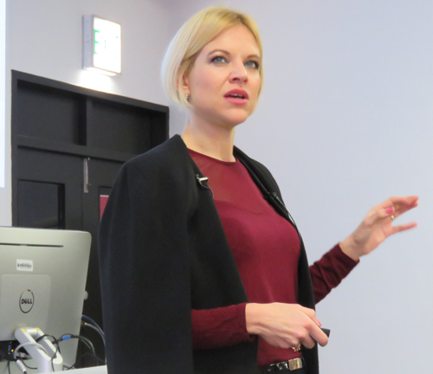
Dr Renata Scheoman addressing the audience on the importance of self-care.
Dr Renata Schoeman, a psychiatrist and senior lecturer in Leadership at USB, delivered a Leader's Angle talk on Wednesday, 10 August about the importance of self-care.
This USB MBA alumnus is a finalist for the Businesswomen's Association of South Africa's Businesswoman of the Year Award for 2016. The winner will be announced on 26 August.
In her presentation, Dr Schoeman said self-care is important in order to "achieve equilibrium across one's personal and professional life".
This balance holds the following benefits:
- Creates a sense of responsibility;
- Provides the opportunity to be a nurturer;
- Makes a connection to other living things;
- Helps us to relax and let go;
- Releases happy hormones;
- Helps us to live in the present moment;
- Reminds us of the cycle of life;
- Allows us to vent anger and aggression;
- Allows us to feel in control; and
- Creates a sense of achievement.

Dr Schoeman's tips for balancing a busy life are:
- Try to stick to a routine.
- Declutter your life of things that doesn't give you joy or is not useful.
- One minute rule: If a task can be done under one minute, do it immediately; don't postpone it.
- 15 minutes is enough: When you are waiting for 15 minutes, it is not too short to read an article, reply on emails or pack away the dishes.
- A full article about her talk, written by Amber Kriel, will be published in the next USBNet newsletter.
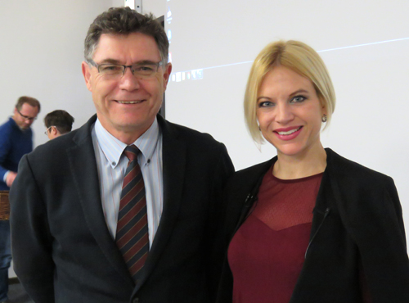
USB director Prof Piet Naudé pictured here with Dr Renata Schoeman.

