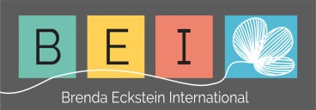

Untethered camel FROM ‘AFRICAN YOGA’
A large camel train passed through the desert and arrived at an oasis, where it was decided to take rest for the night. Drivers and beasts were all anxious to sleep but when it was time to secure the camels, they found that they were short of one hitching-pin. All the camels were duly tied up, except one. The drivers searched for some means to tether the animal but none could be found. No one wanted to stand watch all night and lose the night’s sleep. Yet at the same time the drivers did not want to lose the camel.
After some thought, one of the drivers had a good idea. He went to the camel, took the rope and carefully went through all the motions of tethering the animal to a pin – an imaginary pin. Afterwards the camel was bedded down, convinced that it was securely bound and a good night’s rest was had by all.

The following morning the camels were released. Everyone made ready to continue the journey, except one camel. It refused to get up. The drivers cajoled and coaxed but the beast would not move. Eventually one of the drivers realised the reason for the camel’s obstinacy. He stood before the imaginary hitching-pin and went through all the usual motions of untying the rope and releasing the animal. Immediately afterwards, the camel stood up without the slightest hesitation, believing that it was not free.

Of course the camel had been free all the time but it had allowed itself to be convinced that it was bound. It is the same with each human being – he too is always potentially free but most people allow themselves to be bound by their mental problems and seemingly oppressive responsibilities. You are really as free as the unpegged camel, yet through conditioning and misconceptions, you think that you are firmly bound. You compare yourself with others, in the same way as the camel did and automatically believe that you are limited. But you are really free – understand this.

Paramahamsa Satyananda
